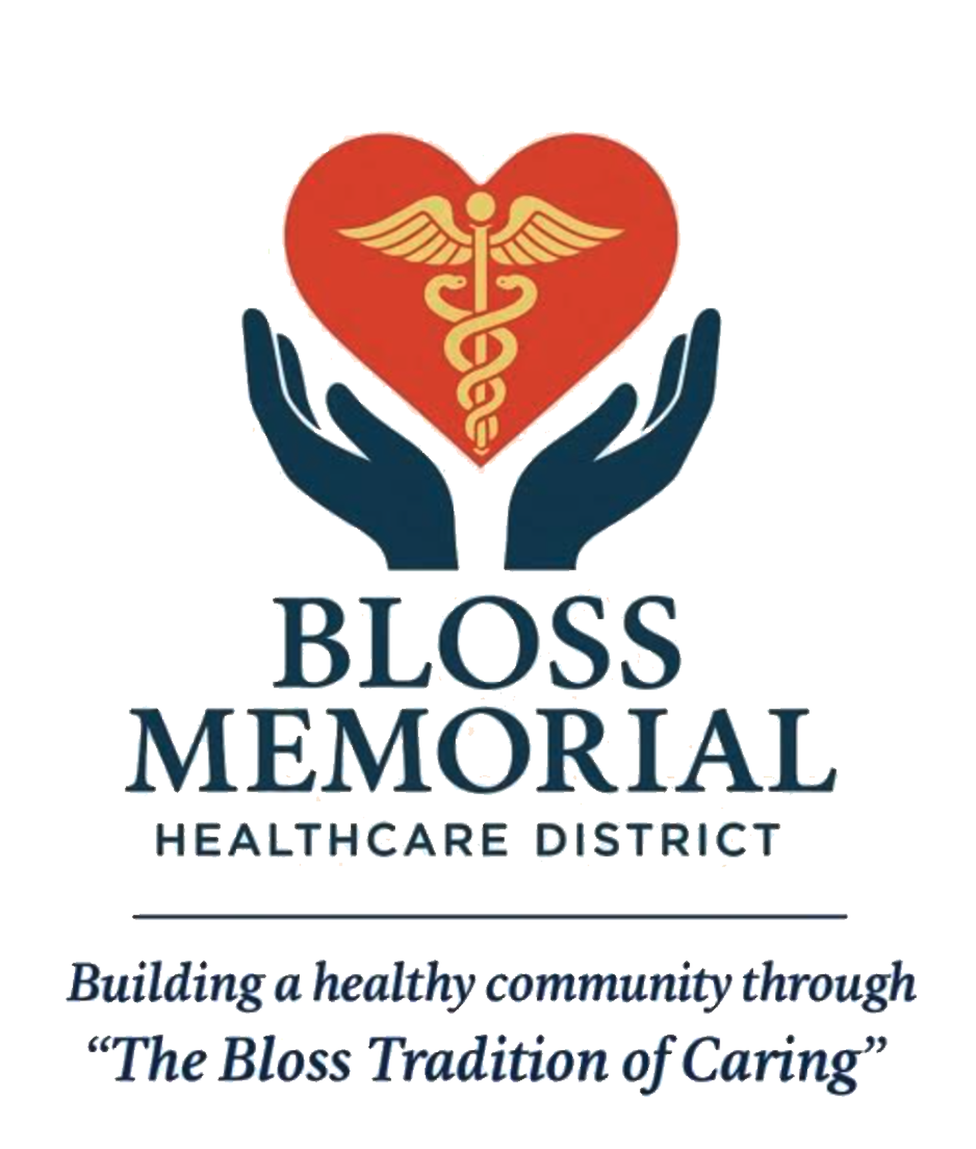
Bloss Memorial Healthcare District
Scholarship Application
Purpose
The Bloss Memorial Healthcare District (BMHD) Scholarship supports students pursuing education and careers in healthcare fields that enhance the well-being of our community.
Applicant Information
Full Name
Mailing Address
City, State, Zip
Phone Number
Email Address
Date of Birth

Education Information
High School or Current Institution
Graduation Date (or expected)
College or Program Attending
Intended Major/Field of Study
Degree or Certification Sought
Enrolment Status | Full Time ☐ Part Time ☐

Healthcare Career Interest
Please describe your career goals and how that align with the mission of Bloss Memorial Healthcare District.

Essay Prompt
Attach a 500 -750 word essay sharing your personal statement and how your education and career will contribute to improving healthcare access, quality, or outcomes in the Bloss Memorial Healthcare District service area?
Letters of Recommendation
Please provide two letters of recommendation, if available, from:
- A teacher, professor, or academic advisor
- A community leader, employer, or healthcare professional
Transcripts
Attach a copy of your most recent official or unofficial transcript, if applicable.
Certification and Signature
I certify that the information provided in this application is true and complete to the best of my knowledge. I understand that false statements may disqualify me from consideration.

Signature |  | Date

Submission Instructions
Submit application and required materials between January 1, 2026, and February 28, 2026, via mail to:

Bloss Memorial Healthcare District
Attention: Scholarship Committee
257 E. Bellevue Road #334
Atwater, California, 95301

